**User Manual of Case Detail Page:**

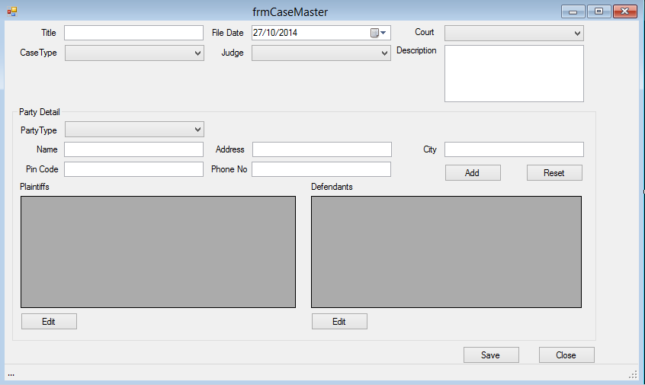

* This is the case master form, from where the advocate can view the details of a case like Case title, case type, file date, judge and court assigned for the respective case.
* Advocate can add and reset the party details of the respective cases like party type, name, address, city, phone no and pin code.
* Advocate can add the plaintiff details and defendant details separately in the same form.